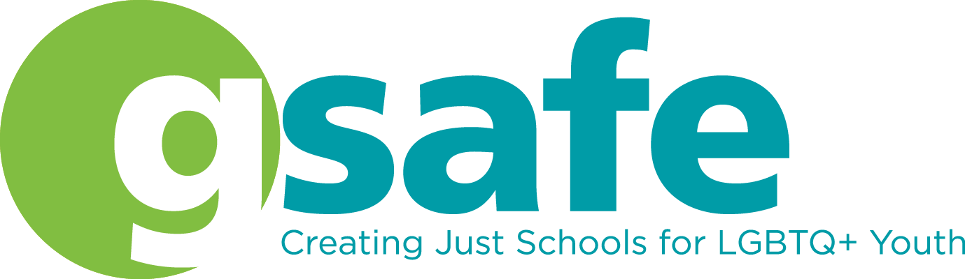
GSAFE increases the capacity of LGBTQ+ students, educators, and families to create schools in Wisconsin where all youth thrive.
Thank you for your contribution to our silent auction! Please complete this form and return by email to quilts@gsafewi.org or along with your item(s) to GSAFE, 122 E Olin Ave Ste 100, Madison, WI 53713 by October 31st. Please contact GSAFE at the address above or text 608.235.5467 to arrange for donation drop off or pick up.

Donor Name (Contact Person): __________________________________________________

Donated By (as it should appear in the program): ____________________________________

❐ Please list my donation as anonymous

Full Mailing Address: _________________________________________________________

____________________________________________________________________________

Phone: _____________________ Email: __________________________________________

Name of Item: ________________________________________________________________

Item Dimensions: _____________________________________________________________

Fair Market Value of Item (value of materials + your time & talent!): _____________________

Item Description (Please provide a few sentences about your item that we can include with your item’s listing. Please point out details folks should notice and appreciate!):

Our customers love the stories behind the items! Please consider providing comments about what makes your item special and/or why you support GSAFE’s work to support LGBTQ+ work:

NOTE: Photos of you with your item and/or item in progress are encouraged and appreciated and might be used for promotional purposes. Please email photos to quilts@gsafewi.org.

How will we receive your item?

❐ Donor will Deliver ❐ Committee to Pick Up (to the best of our ability)

Donor Signature: _____________________________________________ Date: ___________

Your time, talent, and financial generosity is greatly appreciated. Together we’re helping create schools where LGBTQ+ youth are safe, included, and affirmed. Thank you!

BONUS: You will receive a letter acknowledging your fully tax-deductible donation in Jan, 2022!

