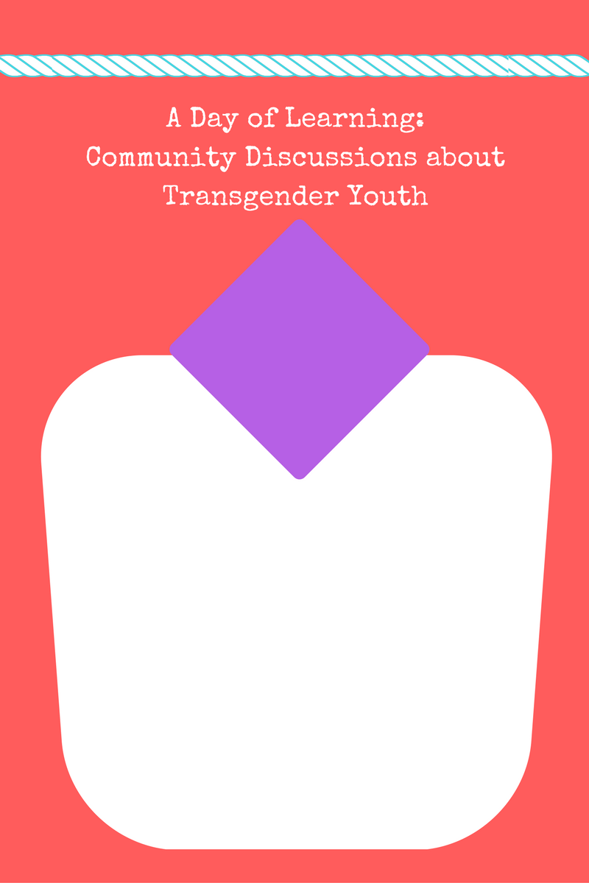



**Date:**

**Time:**

**Location:**

Join us at a Day of Learning!

What does it mean to be young and transgender? Please join us for a community conversation to help increase awareness and understanding around this topic. There will be time for discussions, questions, and information you can take home.

This is a family-friendly event; children are encouraged and welcome.

**Please bring a food item for a treat or snack if you are able.**

**We would love to have at least one option that is allergen friendly.**

We are looking forward to seeing you there for a Day of Learning!

Have questions? Please call ____________ at _______________