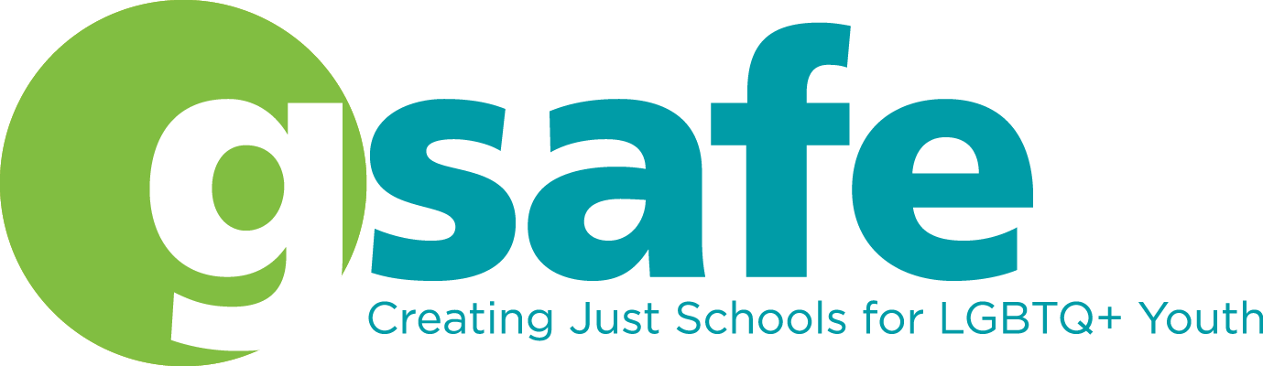
GSAFE increases the capacity of LGBTQ+ students, educators, and families to create schools in Wisconsin where all youth thrive.
Thank you for your contribution to our silent auction! Please complete this form and return by email to quilts@gsafewi.org or by mail to GSAFE, 122 E Olin Ave, Ste 100, Madison, WI 53713. Please contact GSAFE at the address above to arrange for donation drop off or pick up.

Donor Name (Contact Person): ___________________________________________________

Donated by (as it should appear in the program): _____________________________________

Mailing Address: ______________________________________________________________

Phone: _____________________ Email: __________________________________________

Name of Item: ______________________________________ Donor’s stated value: ________

Please provide a brief description of the item you are donating:

Please provide any special comments about the item and/or why you support GSAFE’s work to support LGBTQ+ work (optional):

❐Anonymous Donation ❐ Donor will Deliver ❐ Committee to Pick Up

Donor Signature: _____________________________________________ Date: ___________

